1. Write an OPENGL app to draw primitives such as a line and unfilled rectangle, triangle, hexagon.
2. Write an OPENGL app draws following polygons: red square, blure triangle and green pentagon at the same location and style.

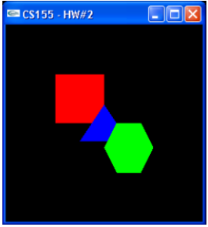

1. Write a OPENGL app to animate bouncing square.
2. Write a OPENGL app to draw red square at the plate of mouse click.
3. Write a OPENGL app to display following vehicle.

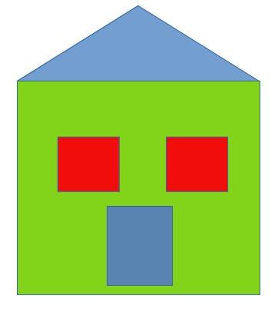

1. Write an OPENGL app to generate 50 random points and plot them.
2. Write an OPENGL app to draw red filled square at the point of click.
3. Implement direct method to draw a line given two ends points.
4. Implement DDA to draw line given two end points of line.
5. Compare time taken to draw given line using direct method, DDA and Bresenham.
6. Implement mid point algorithm to draw circle given its radius and center.
7. Implement mid point algorithm to draw ellipse given its primary, secondary axis and center.
8. Draw a rectangle with given x,y, width and height then translate it by (20,20) using opengl function
9. Draw a rectangle with given x,y, width and height then rotate it by 30 degree clockwise using opengl function
10. Draw a rectangle with given x,y, width and height then scale it by (2,2) using opengl function
11. Draw a rectangle with given x,y, width and height then translate it by (20,20) without using opengl function
12. Draw a rectangle with given x,y, width and height then rotate it by 30 degree clockwise without using opengl function
13. Draw a rectangle with given x,y, width and height then then perform model transformation by scaling it by (2,2) without using opengl function